DA11 App Trader Project

Team Toy Story: Adell Daly, Hayley Madden, Karen Delapaz, Yari McMurty

**Purchase Recommendation**

**10 Most Profitable Apps With Highest Presumed Usage**

We were tasked with exploring the apps that are made available through the Apple App Store and Android Play Store in an effort to gain insight to determine the best possible purchases for App Trader. Factors our team took into consideration include highest review count, highest rating, and highest profit over the estimated lifespan of the app with a consideration into the specific genre over both stores.

Below, find the 10 Apps team Toy Story recommends purchasing based primarily on profitability, and subsequently on number of customer reviews.

| **Name** | **Purchase Price** | **Lifetime Profit** |
| --- | --- | --- |
| **PewDiePie's Tuber Simulator** | $10,000.00 | $1,178,000.00 |
| **Instagram** | $10,000.00 | $1,070,000.00 |
| **Subway Surfers** | $10,000.00 | $1,070,000.00 |
| **WhatsApp Messenger** | $10,000.00 | $1,070,000.00 |
| **Clash of Clans** | $10,000.00 | $1,070,000.00 |
| **Candy Crush Saga** | $10,000.00 | $1,070,000.00 |
| **Clash Royale** | $10,000.00 | $1,070,000.00 |
| **My Talking Tom** | $10,000.00 | $1,070,000.00 |
| **Pou** | $10,000.00 | $1,070,000.00 |
| **Temple Run 2** | $10,000.00 | $1,070,000.00 |
| **GRAND TOTAL** | **$100,000.00** | **$10,808,000.00** |

By identifying apps with the longest estimated lifespan and the highest rating we were able to determine the highest grossing app to be PewDiePie's Tuber Simulator with a lifetime profit of $1,178,000.00.

The remaining 9 apps all netted the same lifetime profit of $1,070,000.00.

Because there were a large number of apps with the same lifetime profit of $1,070,000.00, apps with the highest number of customer reviews were selected with the assumption a higher number of reviews translates into a higher number of users *(implied user count)*.

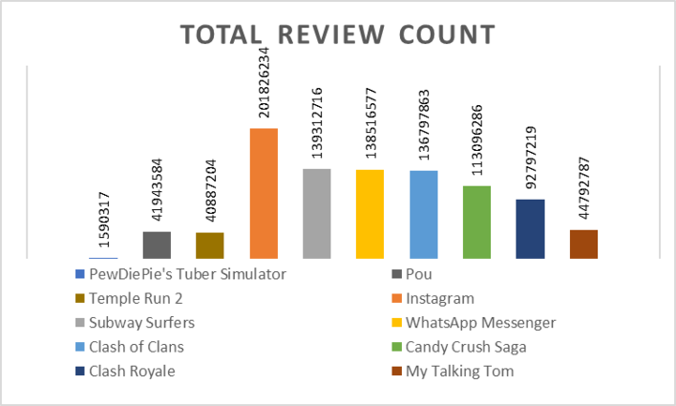

**Strengths**

The selected apps represent the most profitable apps with the highest usage over the expected lifespan of the app.

* This eliminates the risk of App Trader losing income on any of the identified purchases
* This ensures a greater likelihood of user retention and continued usage throughout the app’s expected lifespan.
* Should App Trader choose to pursue additional profit beyond expected monthly income, they will reach the largest audience by purchasing apps with higher implied user counts

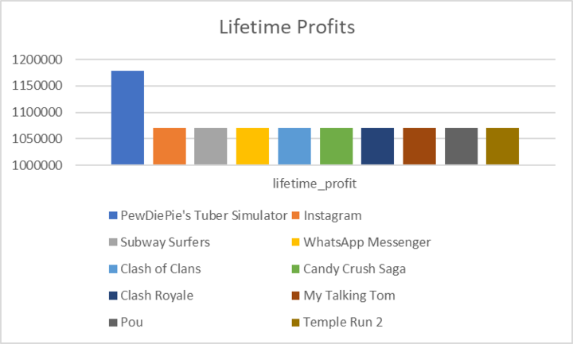

**Weaknesses**

These recommendations are impacted by limited data, including

* Lack of background information related to data used to make recommendations, such as source information, references, and ability to verify correctness
* Lack of user demographic data
* Discrepancies and redundancies between Apple App Store and Android Play Store data.

We propose App Trader request additional data for the recommended apps ahead of purchase. App Trader should use these recommendations as a starting point for additional research.

**Opportunities**

By making recommendations based on the highest implied user count, we determined the potential for in-app purchases and advertising revenue could be higher on the apps with the highest number of reviews as well as the highest average review. This creates opportunity for additional income streams for the same investment cost.

Furthermore, App Trader also has the advantage of creating a relationship with a younger demographic who are likely to download and use more apps as they age and technology needs begin to shift from entertainment and social media to other areas like productivity and finance.

**Threats**

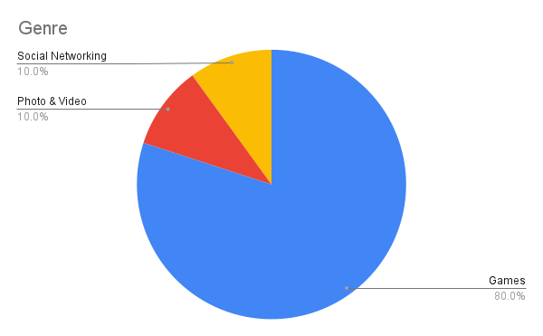

Threats that might limit these purchases include changing target demographics. App Trader may have to adjust marketing spend over the course of an app’s lifetime to attract and retain new users, especially those that are targeted towards a younger audience. This is particularly applicable to Apps categorized as Games - 80% of our recommended purchases.

We strongly recommend App Trader purchase the apps detailed herein, which will provide App Trader with the highest return on investment. The apps also have the largest implied user count, which could lead to additional income streams from in-app purchases as well as potential advertising income.

| **Name** |  |
| --- | --- |
| **PewDiePie's Tuber Simulator** | **Candy Crush Saga** |
| **Instagram** | **Clash Royale** |
| **Subway Surfers** | **My Talking Tom** |
| **WhatsApp Messenger** | **Pou** |
| **Clash of Clans** | **Temple Run 2** |